International Association for Pattern Recognition

TC 11 (Reading Systems)

Biennial Report
to the
Executive Committee and Governing Board
November 2012

Prof. Daniel Lopresti (Lehigh University, USA), TC11 Chair
Prof. Koichi Kise (Osaka Prefecture University, Japan), TC11 Vice Chair
http://www.iapr-tc11.org/

- TC Background Information
  - Listing of TC Leadership Team
For the past four years, the following leadership team has been in charge of pursuing our goal of supporting the research community and its activities.

Role | Name | Affiliation | Email
Chair | Daniel Lopresti | Lehigh University,  USA | lopresti@cse.lehigh.edu
Vice Chair | Koichi Kise | Osaka Prefecture  University, Japan | kise@cs.osakafu-u.ac.jp
Webmaster | Masakazu  Iwamura | Osaka Prefecture  University, Japan | masa@cs.osakafu-u.ac.jp
Dataset Curator | Dimos Karatzas | Universitat Autónoma  de Barcelona, Spain | dimos@cvc.uab.es
Newsletter Editor | Gernot Fink | TU Dortmund  University, Germany | Gernot.Fink@tu-dortmund.de

  - TC website URL
http://www.iapr-tc11.org/

  - Number of members (people on mailing list)
As of November 10th, 2012, there are 1,544 subscribers to the TC-11 mailing list.

  - Communication types used (e.g. newsletters) and frequency
For the period 2010-2012, we continued to employ two types of communication: web and newsletters. The frequency of the newsletter is monthly and has been extremely dependable thanks to the attention and efforts of our newsletter editor. Past newsletters are archived online on our website: http://www.iapr-tc11.org/mediawiki/index.php/Newsletter_Archive.

  - Listing of key event(s) usually organised by the TC
TC11 has the following three key events held biennially:
Event |  | Frequency | Topic area
ICDAR | International Conference on Document Analysis and Recognition | biennial,  odd years | all fields on document analysis and recognition
ICFHR | International Conference on Frontiers in Handwriting Recognition | biennial,  even years | handwriting recognition and its related areas
DAS | International Workshop on Document Analysis Systems | biennial,  even years | document analysis methods and systems

In addition, TC11 and its members are involved in the following workshops which are held in conjunction with major events such as ICDAR:
Event |  | Frequency | Topic area
AND | International Workshop on Analytics for Noisy Unstructured Text Data | annual | issues related to noisy text data by processing signals for human use
CBDAR | International Workshop on Camera-Based Document Analysis and Recognition | biennial,  odd years | camera-based analysis of documents
MOCR | International Workshop on Multilingual OCR | biennial,  odd years | methodologies for multilingual document analysis systems with particular focus on OCR
HIP | Historical Document Imaging and Processing | first held in 2011 | imaging, collection, and processing of historical documents

- Activities in the last two years (since ICPR2010)
We continued our activities with the same leadership team.

  - Website updates
The TC11 website was renovated in April 2010. We have continued to maintain/update the new TC11 website.
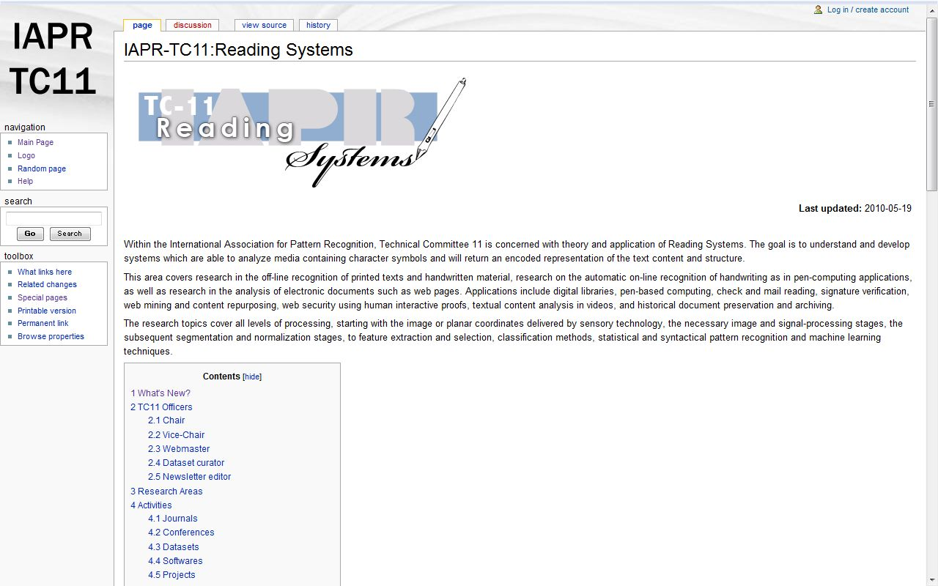

    - Educational information
The primary responsibility of the TC-11 leadership team is supporting the international research community. In this sense, nearly everything we do has an educational component to it. By this we mean that students benefit as much as any other member of the community through attendance at our conferences and workshops. In addition, certain efforts are directed specifically at students to contribute to their training and to the successful development of their careers, as well as to encourage their continued involvement in the field. The following is a list of activities already in place, as well as several that are currently under discussion:

    - Best student paper awards at our conferences
At our three major conferences -- ICDAR, DAS and ICFHR -- IAPR Best Student Paper Awards are given to encourage students. See, for example, the following websites for more details.
ICDAR: http://www.icdar2011.org/EN/column/column34.shtml
DAS: http://www.ict.griffith.edu.au/das2012/awards.html
ICFHR: http://www.icfhr2012.uniba.it/awards.php
    - Support for lower student registration fees at our conferences
Students are always allowed to have lower registration fees at all conferences. In addition, efforts are also made to arrange for lower-cost student accommodations when possible.
    - ICDAR Doctoral Consortium
A major accomplishment over the past two years was our successful organization of the first ICDAR Doctoral Consortium at ICDAR2011 in Beijing. Summarizing our publicity materials for the event:
“The goal of the Doctoral Consortium is to create an opportunity for Ph.D. students to test their research ideas, present their current progress and future plans, and receive constructive criticism and insights related to their future work and career perspectives. A mentor (a senior researcher who is active in the field) has been assigned to each student to provide individual feedback. In addition, students will have the opportunity to present an overview of their research plan during a special poster session. A Best Poster Presentation Award will be given at the end of the day.”
Through an open call for participation, 21 Ph.D. students participated in this first-ever ICDAR Doctoral Consortium. Thanks to a generous sponsorship provided by Raytheon BBN Technologies, there was no registration charge for the Ph.D. students or their assigned mentors. The event took place the day before the main ICDAR conference, on the afternoon of Sunday, Sept. 18. The schedule was as follows:

1:40 pm – 2:10 pm: Welcome and short talk: “Advice for a Successful Ph.D. Experience” by Professor Daniel Lopresti
2:10 pm – 3:10 pm: Brief oral introductions to student research plans
3:10 pm – 3:25 pm: Coffee break
3:25 pm – 5:25 pm: Student poster session with discussion and feedback
5:25 pm – 5:40 pm: Concluding remarks and Best Poster Presentation Award presentation
Further details regarding the 2011 ICDAR Doctoral Consortium can be found on the conference website:
http://www.icdar2011.org/EN/column/column39.shtml
As well as on the TC-11 website:
http://www.iapr-tc11.org/mediawiki/index.php/ICDAR2011_Doctoral_Consortium

Several other educational activities have been under consideration during the reporting period, but are not yet ready for dissemination. These include:
- Recorded lectures and/or interviews with founders of the field offering their advice to students:
Our observation is that it would be great if we could get senior leaders in the field who have recently retired or who are on the verge of retirement to record an inspirational message for students with their best advice for success. We have tentatively named this the “Living History” video project. Our first guest was Professor George Nagy, as interviewed by Professor Daniel Lopresti. A preliminary version of this video is available online: http://www.youtube.com/watch?v=dGvLEbhbetY
(This version is not yet ready for public release. We are currently evaluating the effort needed to produce acceptable quality archive videos.)
- A contest or prize for getting students to sign up for the TC-11 mailing list.
- A summer school focused on document analysis topics.
- Online tutorials. (Traditional “live” tutorials are often included as part of our major conferences.)

    - Tutorials
See Sect. 2.1.1.

    - Description of application areas
- document processing: image-to-text
- check reading
- postal automation: envelope reading
- forms reading and parsing
- graphics recognition and beautification (Also see: TC-10)
- musical score reading
- mathematical equation reading
- signature verification
- pen computing

    - Examples of successful projects
There are many examples of successful projects within the research community, but the TC itself does not engage in projects beyond those described elsewhere in this report.

    - Demos
See the above Sect. 2.1.4.

    - Reference resources (datasets, evaluation tools)
A priority of TC-11 is to encourage and actively promote the open access to research material and resources related to our research field. In this regard the following actions have taken place over the past year.

TC-11 Offered Resources – Evolution and Outlook
We have continued collecting new datasets and software. Our strategy over the past years has been to attempt to host material directly on the TC-11 site to ensure a stable repository, rather than provide unstable external links to resources. As can be seen in the graph of Figure 1, the majority of datasets on the TC-11 Web site are indeed increasingly hosted by TC-11, while over the past 4 years the total number of datasets linked or archived by TC-11 has quadrupled. We consider this is a major success of TC-11 and an important contribution to the field.
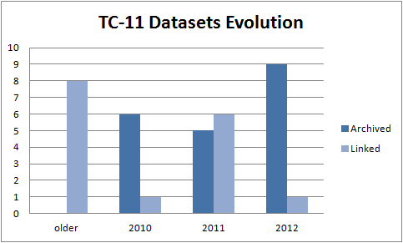
Figure 1. Evolution of the TC-11 datasets over the past four years.
An overview of the current list of resources made available through the TC11 Web site is provided in Table 1.

Table 1. List of resources made available online through the TC11 Web site (compiled Nov 2012)
Resource Name | Submission Date | Status

Complex Text Containers
MSRA Text Detection 500 Database (MSRA-TD500) | Oct 2012 | Archived
The Street View Text Dataset | Oct 2012 | Archived
The Street View House Numbers (SVHN) Dataset | Jan 2012 | Archived
NEOCR: Natural Environment OCR Dataset | Oct 2011 | Archived
KAIST Scene Text Database | Jan 2011 | Archived
ICDAR 2003 Robust Reading Competitions | Jun 2011 | Archived
ICDAR 2005 Robust Reading Competitions | Jun 2011 | Archived

Machine-printed Documents
Table Ground Truth for the UW3 and UNLV datasets | May 2010 | Archived
The DocLab Dataset for Evaluating Table Interpretation Methods | Aug 2010 | Archived
PRImA Layout Analysis Dataset | Jan 2011 | Linked
DFKI Dewarping Contest Dataset (CBDAR 2007) | Mar 2011 | Linked
APTI: Arabic Printed Text Image Database | Nov 2009 | Linked

Graphical Documents
Chem-Infty Dataset | Jun 2010 | Archived
Braille Dataset - Shiraz University | Jul 2011 | Archived
TradeMarks Image Database | Sep 2012 | Linked

Mixed Content Documents
Tobacco800 Document Image Database | Jan 2011 | Linked

Handwritten Documents
ICDAR 2009 Signature Verification Competition | Jan 2012 | Archived
ICFHR 2010 Signature Verification Competition | Jun 2012 | Archived
ICDAR 2011 Signature Verification Competition | Jan 2012 | Archived
ICFHR 2012 Signature Verification Competition | Jun 2012 | Archived
CASIA Online and Offline Chinese Handwriting Databases | Mar 2011 | Linked
CROHME: Online Handwritten Mathematical Expressions | Oct 2012 | Archived
Devanagari Character Dataset | Nov 2010 | Archived
HIT-OR3C | Apr 2012 | Archived
IAM Online Document Database (IAMonDo-database) | Jun 2010 | Archived
IAM On-Line Handwriting Database | Mar 2010 | Linked
UNIPEN database | Aug 2009 | Linked
Nakagawa Lab Online Handwriting Database | Aug 2009 | Linked
The Informal Competition of Recognizing On-line Words (ICROW) | Aug 2009 | Linked
IBN SINA: Arabic manuscripts images | May 2010 | Archived
CEDAR Off-line Handwriting CDROM1 | Aug 2009 | Linked
IAM Database | Aug 2009 | Linked
The GERMANA Dataset | Feb 2011 | Linked
The RODRIGO Dataset | Feb 2011 | Linked
MARG- Medical Article Records Groundtruth | Aug 2009 | Linked
Hindi font samples | Aug 2009 | Linked

Software and Tools
GEDI: Groundtruthing Environment for Document Images | Feb 2011 | Linked
PixLabeler | Jun 2012 | Linked
OCRopus(tm) | Jun 2012 | Linked
The Hidden Markov Model Toolkit (HTK) | Jun 2012 | Linked
Bidirectional Long-Short Term Memory Networks | Jun 2012 | Linked
SRILM - The SRI Language Modeling Toolkit | Jun 2012 | Linked
Torch 5 | Jun 2012 | Linked
PRTools | Jun 2012 | Linked

Policies and Dataset Sourcing Activities
One of the priorities defined at the start of our term was to maintain an active attitude in soliciting datasets and increase the visibility of the TC-11 Web site as the prime place to host datasets and other resources relevant to the field. One way to increase visibility was to announce new material archived through the TC-11 newsletter, giving thus further incentives for authors to submit resources to the TC-11.
On the other hand, we actively invite authors who present new datasets or other relevant material at TC-11 conferences to provide such materials to TC-11 for archiving. This seems to work, by creating good responses especially after TC-11 conferences. As an indication, following this practice over the past year we have archived on the TC-11 site relevant material originally published in the conferences listed below. It can be appreciated that while only TC-11 events were covered until 2009, over the past years the reach of TC-11 has expanded over and above our own events, sourcing relevant resources to the field from an increasing number of leading conferences.

User Interface Aspects
We are in the process of releasing an advanced web interface for submitting material to TC-11, currently under testing, that will allow among others:
- Online submission of material, including uploading of related files
- Downloads counts (which provides an indirect measure of relevance / quality)
- User comments

  - Research Initiatives
    - Events organised
The organized events are listed below. All events are active as shown in the statistics of the number of presented papers as well as participants.
Event | Dates | Venue | Stats & URL
ICDAR2011 | September  18-21,  2011 | Beijing,  China | # submitted papers: 422  # accepted papers: 278  # participants: 387  http://www.icdar2011.org/
DAS2012 | March  27-29,  2012 | Queensland,  Australia | # submitted papers: 131  # accepted papers: 91  # participants: 106  http://www.ict.griffith.edu.au/das2012/
ICFHR2012 | September  18-20,  2012 | Bari,  Italy | # submitted papers: 158  # accepted papers: 132  # participants: over 150  http://www.icfhr2012.uniba.it/

In addition to the above key events, the TC is also involved in several other events, some of which are endorsed by IAPR.

Event | Dates | Venue | URL, etc.
J-MOCR-AND | September 17,  2011 | Beijing,  China | http://www.cubs.buffalo.edu/J-MOCR-AND/index.php  in conjunction with ICDAR2011
HIP | September  16-17,  2011 | Beijing,  China | http://www.comp.nus.edu.sg/~hdocp/  in conjunction with ICDAR2011
CBDAR2011 | September 22  2011 | Beijing,  China | http://imlab.jp/cbdar2011/  in conjunction with ICDAR2011

    - Publicity / dissemination activities
The activities for publicity and dissemination consists of the following four items:
(1) Newsletter
The TC11 newsletter, which is published every month, distributes the following
information to its readership:
* regular content:
- overview of most important conference-related dates
(especially paper submission deadlines)
- overview of new and recently published Datasets (newly introduced 10/2012), which is intended to increase the general awareness of publicly available datasets and to promote their use for benchmarking in future research efforts and related publications
- IJDAR Contents Telegram (introduced 4/2010 in cooperation with IJDAR Editor-in-Chief Simone Marinai; distribution frequency dependent on journal publication schedule)
* on-demand content:
- new/updated calls-for-papers for TC-11 related conferences and workshops as well as journal special issues and books
- detailed announcements of new datasets available via the TC-11 website (in addition to the new overview section on "New and Recently Published Datasets")
- job opportunities
- event reports (conferences, workshops)
Additionally, the newsletter was used to conduct surveys regarding new potential developments in the area of TC-11:
- survey on potential summer school in Document Analysis and Recognition
- survey regarding a doctoral consortium to be held in conjunction with ICDAR 2011

(2) Web
The TC-11 web site provides visitors an up-to-date calendar of upcoming and past events of TC11 interests, newsletter archives, and related datasets.
(3) Domain name
We have registered our TC-11 domain name (IAPR-TC11.ORG) until 2013, at which time we intend to renew the registration.

    - Other
The TC-11 leadership played a role in determining the winners of the IAPR/ICDAR 2011 Awards. We also formed the ICDAR Advisory Board to help manage the bids and determine the location for ICDAR 2015, and determined that ICDAR 2015 will be held in Tunis, Tunisia.

- Plans (timeline until ICPR 2014 and beyond)
We have the following plan for the period 2012-2014. We will continue to advance and to use the TC-11 website, our monthly newsletter, and our dataset collections over the next two years, following the standards established during the previous period led by our Chair whose term is now ending, Professor Daniel Lopresti. In addition, we plan to continue and expand the ICDAR Doctoral Consortium.
- Website: It is our policy to update the website of TC-11 frequently to attract researchers as a reliable source of up-to-date information on reading systems. We will seek opportunities to enrich the web content by collecting educational materials and tutorials, finding successful projects and nice demos, and incorporating these on the website.
- Newsletter: We will continue to issue the newsletter monthly to maintain our current subscriber base as well as to encourage new subscribers.
- Datasets: We believe that providing datasets for evaluation purposes is one of the most important activities of TC-11. Over the next period we plan to expand further the datasets available on the website.
- Software: Another important point for attracting new researchers to the field is to provide freely available software. In addition to datasets, we plan to start collecting software and make it available on the TC-11 website. This will allow researchers to compare their methods to the results obtained by other, published algorithms.

4 Recommendations to ExCo for TC leadership team for 2012-2014 term

Role | Name | Affiliation | Email
Chair | Koichi Kise | Osaka Prefecture  University, Japan | kise@cs.osakafu-u.ac.jp
Vice Chair | Dimosthenis Karatzas | Universitat Autónoma  de Barcelona, Spain | dimos@cvc.uab.es
Webmaster | Masakazu  Iwamura | Osaka Prefecture  University, Japan | masa@cs.osakafu-u.ac.jp
Dataset Curator | Marcus Liwicki | DFKI, Germany | liwicki@dfki.uni-kl.de
Newsletter Editor | Gernot Fink | TU Dortmund  University, Germany | Gernot.Fink@tu-dortmund.de

